Table S1:
Euclidean distance between the input features and predicted features in BVN inference
 | Male | Female
#0 | 2.482541457 | 3.331276657
#1 | 2.720487598 | 2.694632179
#2 | 1.66202945 | 3.809493684
#3 | 3.657397365 | 2.139857406
#4 | 2.389329198 | 4.170589669
#5 | 2.303908441 | 2.019533422
#6 | 3.347863027 | 2.11368229
#7 | 2.182303472 | 1.71244637
#8 | 3.843715168 | 1.880469296
#9 | 1.734531436 | 3.15907759
#10 | 2.808226378 | 3.956929232
#11 | 2.230135848 | 1.253912229
#12 | 2.964873046 | 1.488445363
#13 | 2.817682937 | 2.241708491
#14 | 1.558078357 | 3.944965023
#15 | 1.841580056 | 4.077664846
#16 | 4.204951677 | 1.491057924
#17 | 2.671106759 | 2.851783579
#18 | 2.623997328 | 1.777050773
#19 | 2.779465487 | 2.613932464
#20 | 1.776870163 | 2.670845646
#21 | 0.626026685 | 1.616925062
#22 | 3.212388352 | 2.900317761
#23 | 5.108908067 | 1.562128443
#24 | 4.065310692 | 0.855507847
#25 | 2.742951337 | 1.942464405

Figure S1
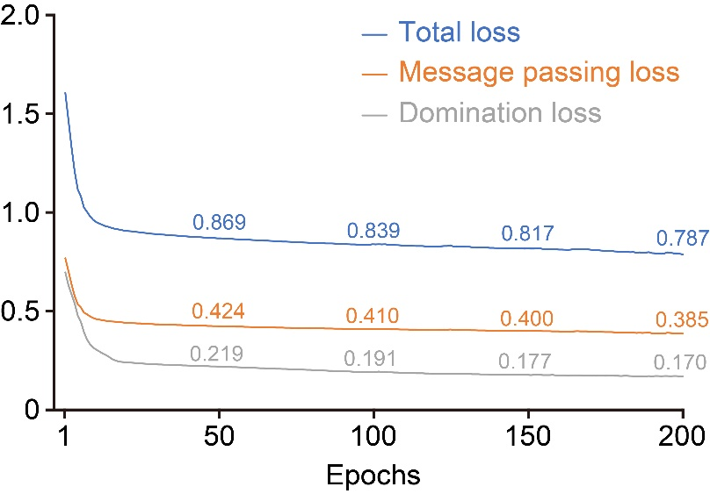
Training loss progression during BVN model training. Changes in total loss, message passing loss, and domination loss over 200 epochs are shown. Total loss was calculated as 2.0 × message passing loss + 0.1 × domination loss. Detailed methods for the loss functions, training targets, and loss calculation procedures have been described in our previous study (Ref. 12).

Figure S2
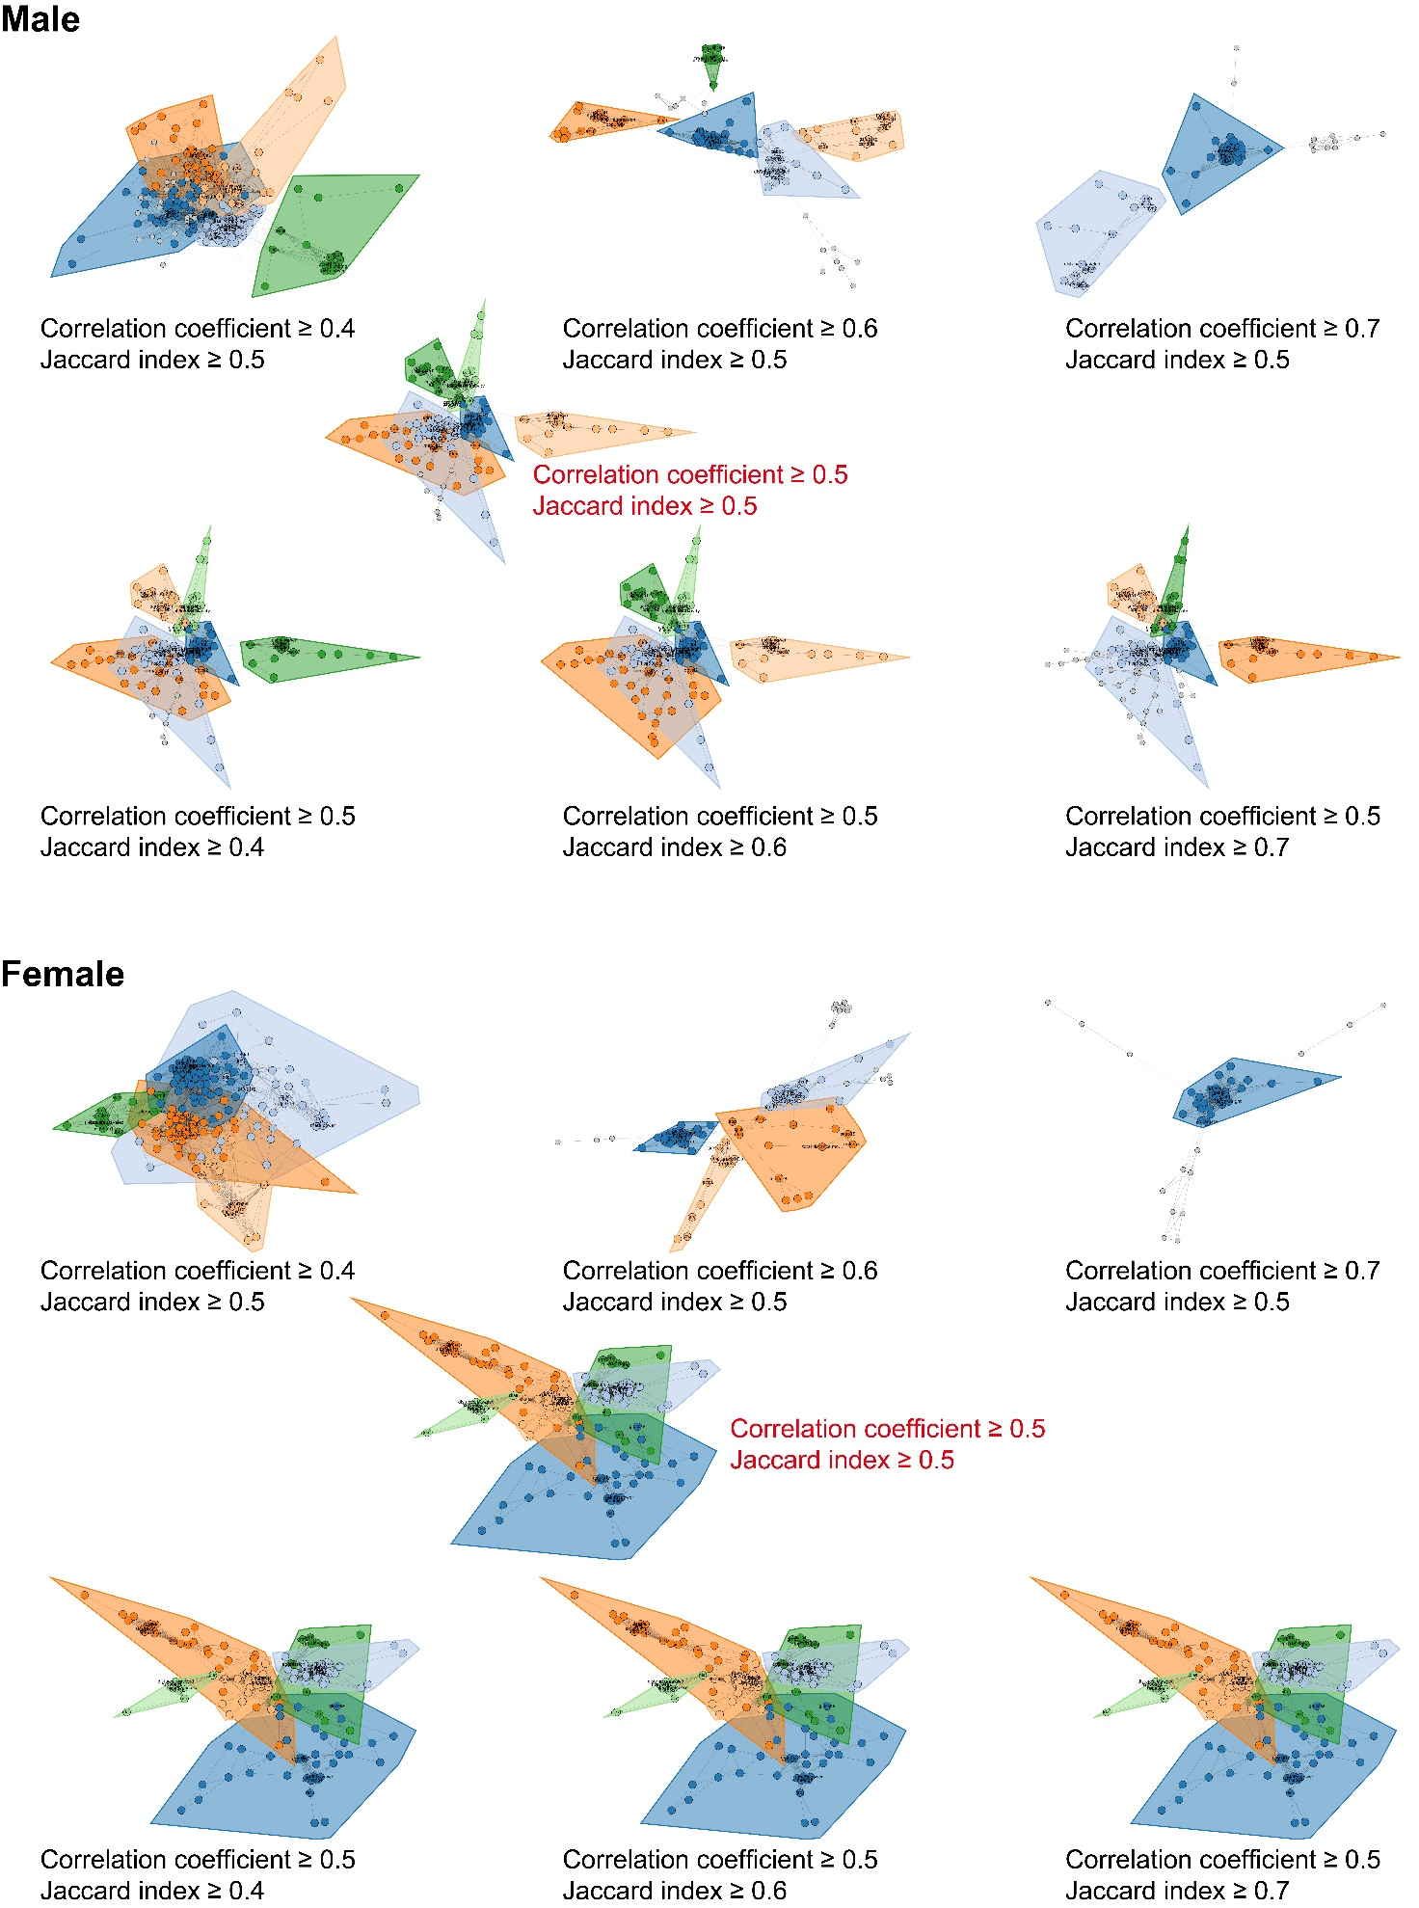
Validation of community classification using different thresholds for Spearman’s correlation coefficient and Jaccard index. Community classification was evaluated using different thresholds for Spearman’s correlation coefficient (upper panels) and Jaccard index (lower panels) in males and females. Colored convex hulls indicate detected communities, whereas gray nodes outside the convex hulls were not included in any community. The thresholds used in the main analysis (correlation coefficient ≥ 0.5 and Jaccard index ≥ 0.5) are highlighted in red. Increasing the correlation coefficient threshold to ≥ 0.6 markedly reduced the number of detected communities in both males and females. In contrast, changes in the Jaccard index threshold had a smaller effect on the overall community structure. In males, community classification was relatively stable at Jaccard index thresholds of 0.4–0.5, whereas higher thresholds resulted in greater changes in community composition.

Figure S3
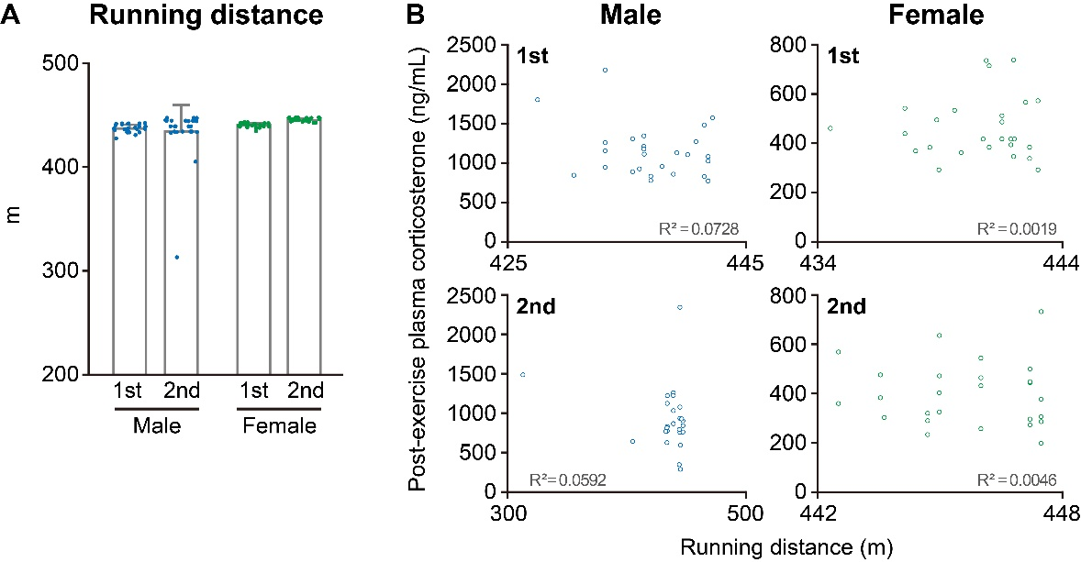
A: Running distance during the first and second acute forced exercise tests in male and female mice. B: Relationship between running distance and post-exercise plasma corticosterone concentration in the first and second acute forced exercise tests in male and female mice.

Figure S4
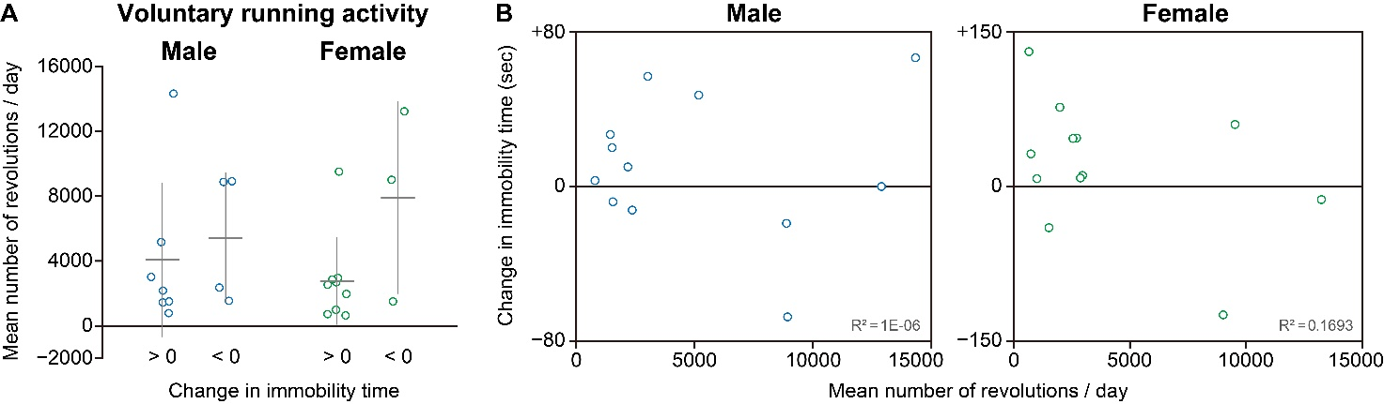
A: Mean daily number of running-wheel revolutions during voluntary exercise combined with chronic restraint stress in male and female mice. Mice were classified according to whether the change in immobility time after chronic restraint stress was > 0 or < 0. B: Relationship between the mean daily number of running-wheel revolutions and the change in immobility time after chronic restraint stress combined with voluntary exercise in male and female mice.

Figure S5
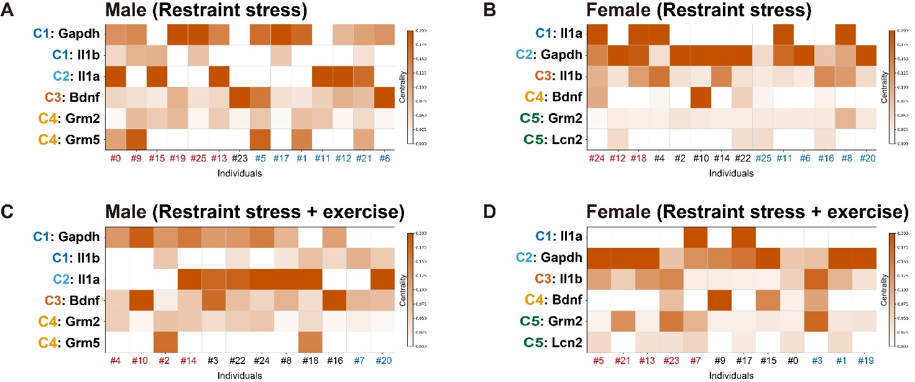
Heatmaps show the summed centrality of input-containing sub-graphs within each community obtained by BVN inference after excluding immobility time from the input data in male mice exposed to chronic restraint stress (A), female mice exposed to chronic restraint stress (B), male mice exposed to chronic restraint stress combined with voluntary exercise (C), and female mice exposed to chronic restraint stress combined with voluntary exercise (D). Stress-susceptible individuals, defined as those showing an increase in immobility time after chronic restraint stress, are indicated in red, whereas resilient individuals, defined as those showing a decrease in immobility time, are indicated in blue. Individuals classified as showing no change in immobility time are indicated in black. The direction of change in immobility time was classified as increased, decreased, or unchanged using a two-step filtering procedure based on control-referenced z scores and robust z scores (see Methods for details).

Figure S6
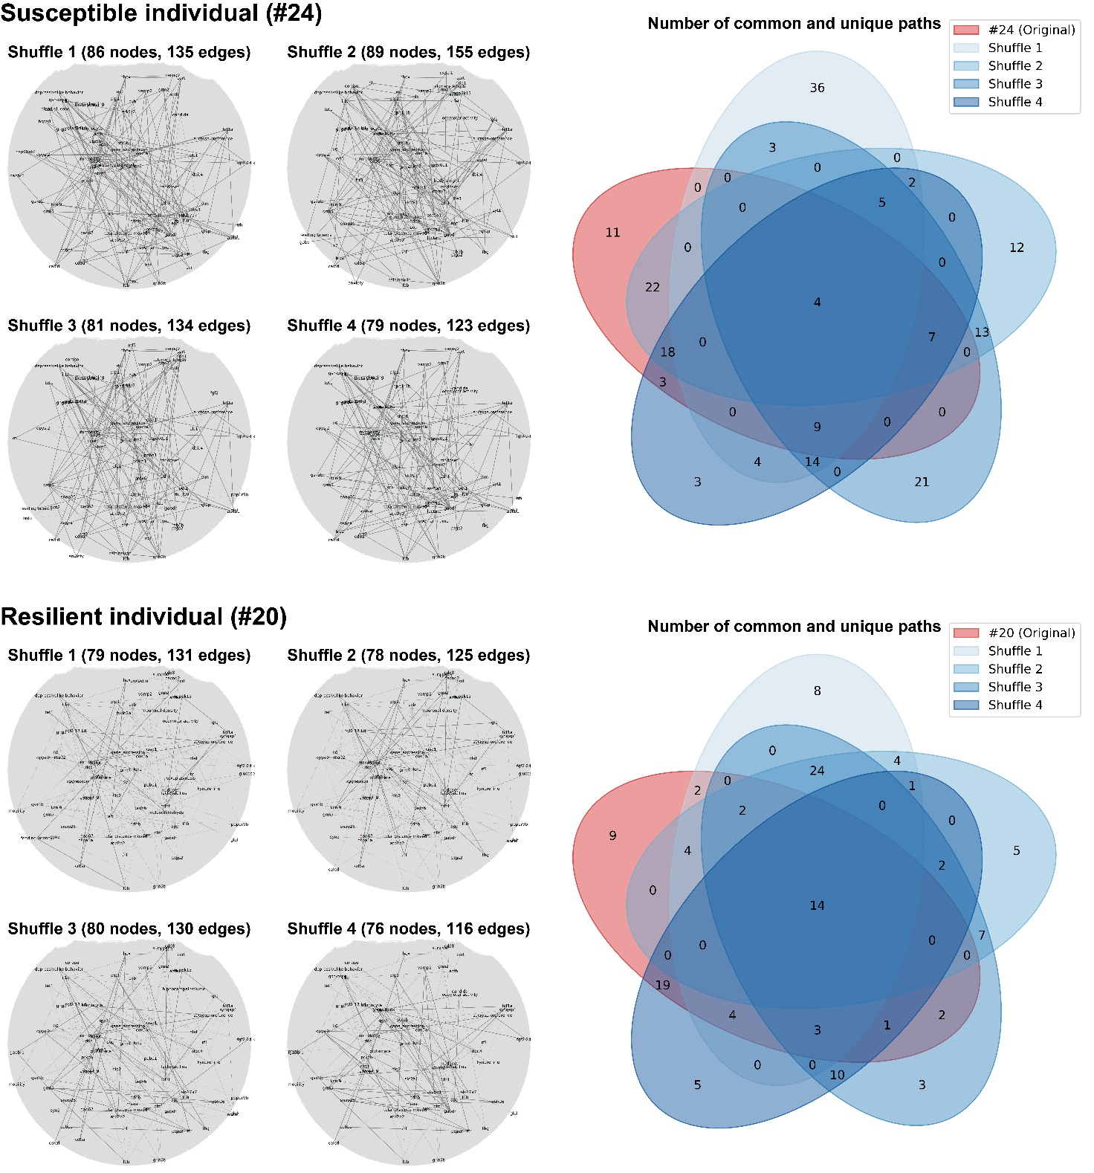
Validation of BVN inference dependence on input data structure using representative individuals. The original input data were randomly shuffled to disrupt the original associations between target variables and their directions of change. Four independently shuffled input datasets were generated for each representative individual and subjected to BVN inference. The upper and lower panels show a stress-susceptible individual (#24) and a resilient individual (#20) in females, respectively. The left panels show the BVN-inferred networks obtained from the four shuffled datasets, together with the number of nodes and edges in each network. The right panels show Venn diagrams comparing the numbers of common and unique inferred paths among the networks obtained from the original and four shuffled input datasets.

